Test Preparation

Create Note Cards

-Note cards are useful for classes for which you need to remember specific facts such as terms, dates, names, or other small, key pieces of information.

-Ideal note cards are easy to organize, are quick to review, and promote self-testing.

-The size of the cards may be 3 x 5, 4 x 6, or 5 x 8 depending on the amount of material to be recorded, handwriting size, and if you include memory boosters such as drawings, pictures, diagrams, charts, or tables.

-When writing a note card:
- Write a key term, question or math or science problem on the front of each card.
  - Turn main points from lectures or textbooks into questions.
  - Put a problem on one side and the solution, step-by-step, on the other.

- Write an explanation of the term (answer the question or work the problem) on the back of the card.
  - For terms, use your own words unless you will be tested on exact definitions.

- Include an example on the back.
  - Often examples are easier to remember than definitions, and can help trigger your recall of information.

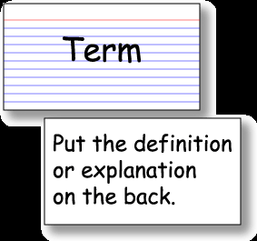

Review for Exams

- Use your calendar system.
  - Plan to start studying at least one week before the exam.
  - Put test review sessions into your calendar and commit to them.

- Write specific study tasks on your “To Do” list and check them off as you accomplish them.

- Review your lecture notes by covering the right-hand section of each page and quizzing yourself from the trigger words you wrote in the left-hand column.
  - You should continue to study until all information is mastered.

- Review your textbook.
  - Re-read your target questions, and circle key terms in your textbooks to ensure you recall the information.
  - Compose your own test questions and try to answer them

- Review your note cards.

Step 1: Look at the term, question or problem on the front of the card.

Step 2: As best as you can, recite aloud the complete details/answer, without looking. If it is a chemistry or math problem, work out the answer on paper, step-by-step.

Step 3: When finished with your answer, turn the note card over and check for completeness and accuracy by looking at the details/answer.

Step 4: If details were correctly recited or answer was correctly written out, place that note card in a pile of “learned” note cards.

Step 5: If details were incorrectly recited or answer incorrectly written out, read the details/answer aloud. Then, with this same note card, repeat steps 1-4 as many times as it takes to answer correctly without looking. Until then, place the note card in a “not yet learned” pile.

